* + it may be hardware or software integrated to perform a particular function. It uses a [Microcontroller](https://www.codrey.com/microcontroller/microcontroller-basics/)/Microprocessor to perform a single job.
  + [microcontroller](https://www.codrey.com/microcontroller/microcontroller-basics/) is an intelligent device that computes the tasks assigned by the user in an efficient manner.
  + The output devices are the indications or results that occur due to input events from outside the microcontroller. Examples of output devices are LCD, LED, Motors, Seven segment displays, Buzzer, Relays etc.
  + Input devices take input from the outside world. Some of the examples of input devices are sensors, switches, photo-diode, optocoupler etc. They accept input from the user and respond accordingly.
  + **Device drivers** are the core software components that control a peripheral device. A device driver is a piece of embedded code written for a particular hardware. The peripheral may be LCD, Touchscreen, UART, USB etc.
  + The open-source **Arduino** Software (**IDE**) makes it easy to write code and upload it to the board. It runs on Windows, Mac OS X, and Linux.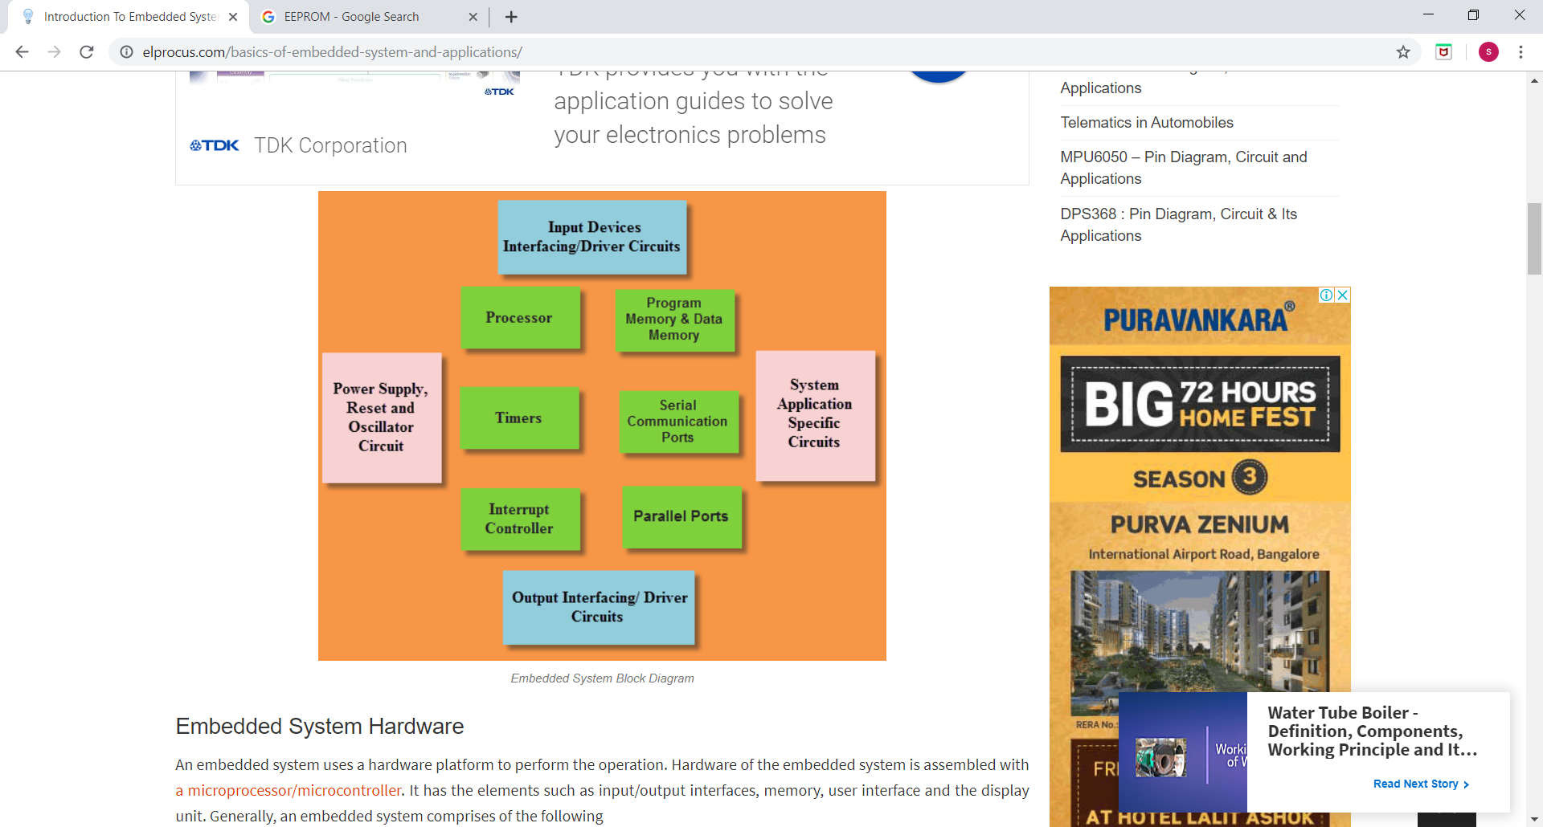

Arduino UNO is quite easy to program. As most of you might have known that in order to program a microcontroller one need to write the code in the editor, and then compile that code in the compiler after which you get the HEX file of that code and later upload that HEX file in the microcontroller IC using another program. In case of Arduino all these steps are performed in single software which is called the Arduino IDE. By integrated Development Environment it means that all the steps that editor, compiler, burner are integrated in the same software. In short Arduino UNO is quite easy to program it is just a matter of few clicks.

* The software used for Arduino devices is called IDE (Integrated Development Environment) . It can be programmed using C and C++ language.
* Arduino board comes with all the features required to run the controller and can be directly connected to the computer through USB cable that is used to transfer the code to the controller using IDE (Integrated Development Environment) software, mainly developed to program Arduino. IDE is equally compatible with Windows, MAC or Linux Systems, however, Windows is preferable to use. Programming languages like C and C++ are used in IDE.
* Microcontrollers are **dedicated** to one task and run one specific program. The program is stored in [ROM](https://computer.howstuffworks.com/rom.htm) (read-only memory) and generally does not change.
* Microcontrollers are "**embedded**" inside some other device (often a consumer product) so that they can control the features or actions of the product.

**Instructions having to do with I/O pins:**

* button - read a button on an input pin, with debounce and auto-repeat
* high - set an I/O pin high
* input - set the direction of an I/O pin to input
* low - set an I/O pin low
* output - set the direction of an I/O pin to output
* pot - read a potentiometer on an I/O pin
* pulsin - read the duration of a pulse coming in on an input pin
* pulsout - send a pulse of a specific duration out on an output pin
* pwm - perform pulse width modulation on an output pin
* reverse - reverse the direction of an I/O pin
* serin - read serial data on an input pin
* serout - write serial data on an output pin
* sound - send a sound of a specific frequency to an output pin
* toggle - toggle the bit on an output pin

8051 MICROCONTROLLER

* 8051 is an 8 – bit Microcontroller
* It is a CISC based Microcontroller with Harvard Architecture (separate program and data memory).

**RELAYS**

### What is a Relay?

A relay is classified into many types, a standard and generally used relay is made up of electromagnets which in general used as a switch. Dictionary says that relay means **the act of passing something from one thing to another**, the same meaning can be applied to this device because the signal received from one side of the device controls the switching operation on the other side. So relay is a switch which controls (open and close) circuits electromechanically. The main operation of this device is to make or break contact with the help of a signal without any human involvement in order to switch it ON or OFF. It is mainly used to control a high powered circuit using a low power signal. Generally a DC signal is used to control circuit which is driven by high voltage like [controlling AC home appliances with DC signals from microcontrollers](https://circuitdigest.com/home-automation-projects).

TYPES.

What we've looked at so far are very general switching relays—but there are quite a few variations on that basic theme, including (and this is by no means an exhaustive list):

* High-voltage relays: These are specifically designed for switching high voltages and currents well beyond the capacity of normal relays (typically up to 10,000 volts and 30 amps).
* Electronic and semiconductor relays (also called solid-state relays or SSRs): These switch currents entirely electronically, with no moving parts, so they're faster, quieter, smaller, more reliable, and last longer than electromagnetic relays. Unfortunately, they're typically more expensive, less efficient, and don't always work as cleanly and predictably (due to issues like leakage currents).
* Timer and time-delay relays: These trigger output currents for a limited period of time (usually from fractions of a second to about 100 hours, or four days).
* Thermal relays: These switch on and off to stop things like [electric motors](https://www.explainthatstuff.com/electricmotors.html) from overheating, a bit like bimetallic strip [thermostats](https://www.explainthatstuff.com/thermostats.html).
* Overcurrent and directional relays: Configured in various different ways, these stop excessive currents from flowing in the wrong direction around a circuit (typically in power-generation, distribution, or supply equipment).
* Differential protection relays: These trigger when there are current or voltage imbalances in two different parts of a circuit.
* Frequency protection relays (sometimes called underfrequency and overfrequency relays): These solid-state devices trigger when the frequency of an alternating current is too high, too low, or both.

### Different Types of Relay:

**Types of Relay Based on the principle of operation**

* **Electrothermal relay:**

**Electromechanical relay:**

**Solid State relay:**

* **Hybrid relay:**

It is the combination of both electromechanical and solid state relays.